Software Project Management
Lecture 1
Introduction to Software Project Management
Course Catalogue
This course covers fundamental concepts of software project management. Topics include:
- Software Project Management
- Managing Project Goals, Time & Costs
- Risk Management; Quality Management
- HR & Communication Management
- Software Project Pricing
- Software Development Management
- Development & Management Standards
Course Objective
To learn the techniques required to plan, organize, monitor and control software development projects.
What is raw material in terms of software?
In software, “raw material” means the basic inputs or resources needed to develop software.
For example:
- Requirements: what the user wants the software to do
- Data: information the software will store or process
- Source code: instructions written by programmers
- Images, videos, text: content used in the software

Standard Definition of Software
Software is a collection of instructions, data, and programs that tell a computer how to work and perform specific tasks.
Software
Software is a product of engineering, just like an airplane, car, or television.
Creating software requires skills, knowledge, and effort.
In manufacturing, raw materials are changed into a physical product.
But software is not manufactured like a physical product. It is developed by writing and testing code.
Types of Software
- System Software
Software that helps the computer work and controls its hardware.
Examples: Windows, Linux, Android.
- Application Software
Software designed to help users perform specific tasks.
Examples: MS Word, WhatsApp, Chrome, Photoshop.
Project
A project is a temporary task or activity that is done to create a specific and unique product or service.
1. Temporary
A project has a specific start and a specific end date.
It ends when:
- The project objectives are achieved, or
- It becomes clear that the objectives cannot be achieved, so the project is terminated (stopped).
- Example: Developing a Hospital Management System from January to June.
2. Unique
- A project creates something that is different in some way from existing products or services.
- It does not necessarily mean that the product is completely new; it has some distinguishing features or purpose.
- Example: Developing a Hospital Management System specifically for a particular hospital with its own requirements.
Management
Management is the process of planning, organizing, and coordinating people and activities so that an organization can achieve its goals effectively and efficiently.
Management means managing people and resources properly to achieve a desired goal.
Example:
A software company manager organizes developers, assigns tasks, manages resources, and makes sure the software is completed on time.
Key points:
- Planning: Decide what to do.
- Organizing: Arrange people and resources.
- Coordinating: Make everyone work together.
- Achieving goals: Complete the desired objectives.

Why We Need Management
- To increase productivity: Management helps us complete more work in less time.
- To avoid time lapse: Management helps us use time properly and avoid unnecessary delays.
- To organize tasks in daily life: Management helps us plan and arrange our daily tasks properly.
- To avoid wastage of resources: Management helps us use resources properly and avoid unnecessary waste.
Responsibilities of Management
- Answerable to stakeholders of an organization: Management is responsible for answering to the people who have an interest in the organization.
- Give employees good working conditions: Management should provide employees with a safe and comfortable workplace.
- Give customers the right thing at the right price and time: Management should provide good products/services at the correct price and on time.
- Maintain good relationships with suppliers: Management should keep good relationships with the suppliers who provide materials and services.
- Develop future plans of the organization: Management should make plans for the future growth and success of the organization.
- Develop and ensure community support: Management should maintain good relations and support from the local community so that they accept your products.
- Know-how of government rules and regulations: Management should know and follow the rules and regulations made by the government.
- Awareness of currency fluctuation and interest rates: Management should be aware of changes in currency values and interest rates because they can affect the organization.
- Preparation against disasters: Management should prepare plans to deal with disasters or emergencies.
- Capability to manage change: Management should be able to handle and manage changes in the organization.
Suppliers
Suppliers can provide the tools and services needed to develop and run software.
Examples:
- Cloud service provider: provides servers and cloud storage, e.g., AWS.
- Software provider: provides software/tools needed by developers.
- Hardware supplier: provides computers and servers.
- Internet service provider (ISP): provides internet connectivity.
Example:
A software company uses AWS cloud servers to run its application. AWS is a supplier/service provider for that company.
Community support
Community support means getting support and cooperation from the people in the local community where the organization operates.
Example:
A software company organizes free programming workshops for local students. This helps build good relations and support from the community.
Management Activities
Management involves the following activities:
- Planning: Deciding what is to be done.
- Organizing: Making arrangements.
- Staffing: Selecting the right people for the job.
- Directing: Giving instructions.
- Monitoring: Checking the progress.
- Controlling: Taking action to solve problems or delays.
- Innovating: Coming up with new solutions or ideas.
- Representing: Liaising with users (Communicating and maintaining relationships with users and others).

Project Management
It is the discipline of planning, organizing, and managing resources to bring about the successful completion of specific project goals and objectives.
Project Management is the art of maximizing the probability that a project delivers its goals
- on Time
- within Budget
- at the required Quality.
Project Management
It is the application of knowledge, skills, tools, and techniques to project activities to meet project requirements.
The more you know about your project, the better you are able to manage it.
Following are Related to Project Management
Professional Organizations:
- Project Management Institute (PMI): An organization related to project management.
- Software Engineering Institute (SEI): An organization related to software engineering and project management.
- IEEE Software Engineering Group: A professional group related to software engineering.
Certifications:
- PMI’s PMP (Project Management Professional): A professional certification in project management.
- CAPM (Certified Associate in Project Management): A certification for people who are starting in project management.
PMBOK: PMI’s Project Management Body of Knowledge. It provides knowledge, guidelines, and practices related to project management.

Project Management Skills
- Leadership: Ability to guide and lead the project team.
- Communications: Ability to clearly share information with team members and stakeholders.
- Problem Solving: Ability to identify problems and find suitable solutions.
- Negotiating: Ability to reach an agreement between different people or groups.
- Influencing the Organization: Ability to influence people and decisions to support the project.
- Mentoring: Ability to guide and help team members improve their skills.
- Process and Technical Expertise: Knowledge of the processes and technical skills needed to manage the project (What to use like top up approach or bottom down approach and which model like agile or waterfall to use).
Leader Vs Mentor Vs Manager
Leader: A person who has knowledge and experience of the work and guides others.
Mentor: A person who guides, teaches, and helps others improve their skills.
Manager: A person who plans, organizes, and manages the work and takes responsibility for getting it done.
PMBOK
- Project Management Process Groups
- Project Management Knowledge Areas

Project Management Body of Knowledge (PMBOK)
- PMBOK: It is a collection of processes and knowledge areas that are generally accepted as best practices in project management.
- Generally accepted: It means these practices can be applied to most projects most of the time.
- Third Edition (2004): It was recognized as a standard by the Institute of Electrical and Electronics Engineers (IEEE 1490-2003).
- Fourth Edition (2008): It was recognized by the American National Standards Institute (ANSI) as an American National Standard (ANSI/PMI 99-001-2008).
Project Management Process Groups
PMBOK recognizes 5 basic process groups:
- Initiating: Starting the project and defining its basic purpose.
- Planning: Deciding what needs to be done and how the project will be completed.
- Executing: Carrying out the planned work.
- Monitoring and Controlling: Checking the progress and taking corrective actions when needed.
- Closing: Finishing the project properly and officially ending it.

Project Management Knowledge Areas
PMI has suggested 9 Knowledge Areas:
- Project Integration Management: Coordinating and combining all parts of the project.
- Project Scope Management: Deciding what work is included in the project.
- Project Time Management: Planning and managing the time needed to complete the project.
- Project Cost Management: Planning and controlling the project budget.
- Project Quality Management: Making sure the project meets the required quality.
- Project Human Resource Management: Managing the people working on the project.
- Project Communications Management: Sharing the right information with the right people at the right time.
- Project Risk Management: Identifying and managing possible risks or problems.
- Project Procurement Management: Managing the purchase of products or services needed for the project.

Software Project Management
- Software Project Management: A part of project management where software projects are planned, monitored, and controlled.
- Software development is a complex task: It involves many people working together for a long period of time.
- Therefore, software projects need to be managed: Because many people, tasks, resources, and time are involved, proper management is needed to complete the project successfully.
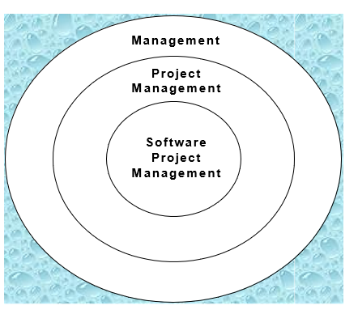

Interaction / Stakeholders
As a Project Manager (PM), who do you interact with?
As a PM, you interact with different project stakeholders, such as:
- Project Sponsor: Provides support, resources, and funding for the project.
- Executives: Senior people who make important decisions for the organization.
- Team: People who work on the project and complete the tasks.
- Customers: People who use or pay for the software and provide requirements.
- Functional Managers: Managers who manage employees and resources in different departments.
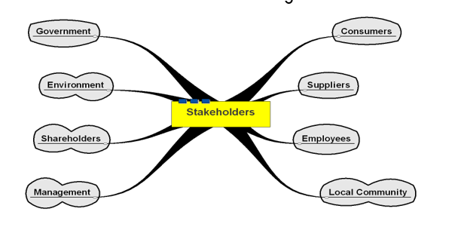
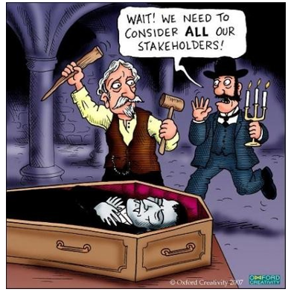
Project Management Tools
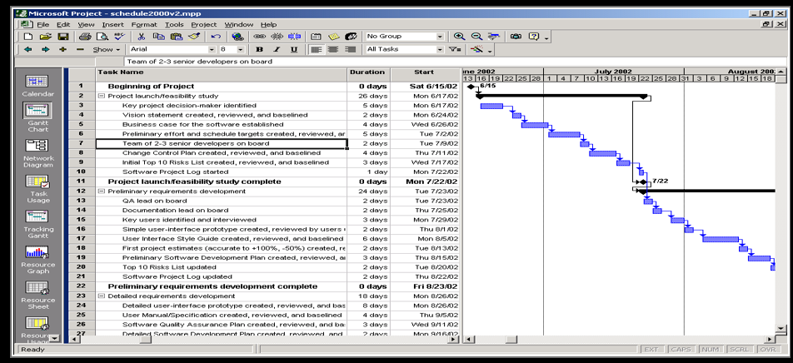
PM Tools: Software
Low-end
- Basic features, tasks management, charting
- MS Excel, Milestones Simplicity
Mid-market
- Handle larger projects, multiple projects, analysis tools
- MS Project (approx. 50% of market)
High-end
- Very large projects, specialized needs, enterprise
- Primavera Project Manager

Lecture 2
Project Lifecycle
Project Life Cycle
Divide a project into different phases to make it easier to manage and control the project, while keeping it connected with ongoing operations.
Project life cycle defines:
- What technical work needs to be done in each phase.
- What deliverables will be produced in each phase and how they are reviewed, checked, and approved.
- Who is involved in each phase.
- How each phase is controlled and approved.
The Project Life Cycle Structure
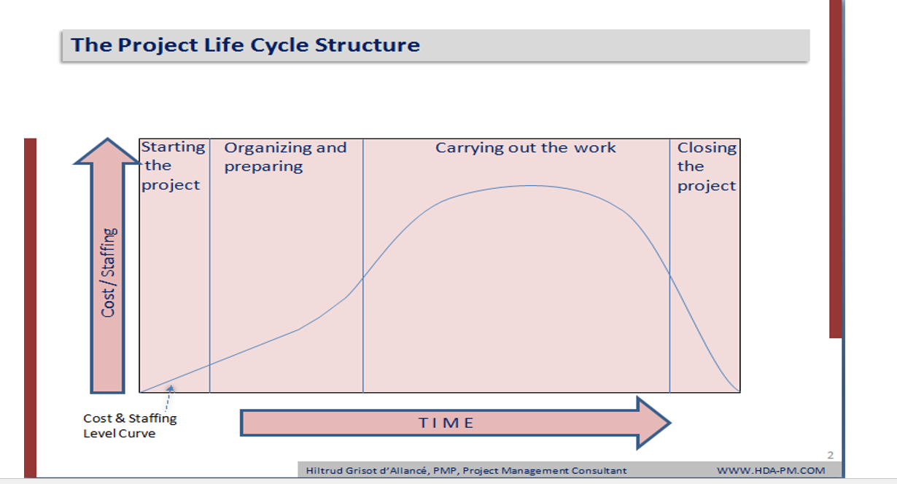

Illustration of Above Graph
The graph shows how cost and staffing levels change over time during the four main phases of a project:
- Starting the project: Cost and staffing are very low because the project idea, scope, and basic plans are being defined.
- Organizing and preparing: Cost and staffing start increasing as detailed plans, schedules, and teams are prepared.
- Carrying out the work: Cost and staffing reach their highest level because most of the actual project work is done in this phase.
- Closing the project: Cost and staffing decrease quickly as the work is completed, final deliverables are handed over, and the project is closed.
Characteristics of The Project Life Cycle
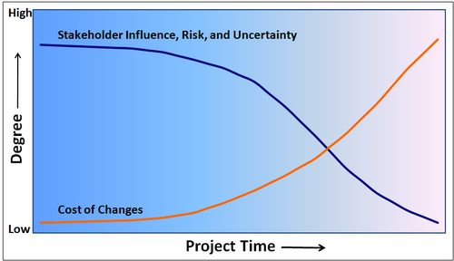

Illustration of Above Graph
This graph illustrates the relationship between project dynamics and time across a project's life cycle
Stakeholder Influence, Risk, and Uncertainty (Dark Blue Line)
- Stakeholder Influence: Stakeholders have the most influence at the beginning because requirements and project decisions are still open to changes. As the project progresses and decisions are finalized, their ability to make major changes decreases.
- Risk: Risk is high at the beginning because many things about the project are not yet known. As the project progresses and more work is completed, risks are identified and managed, so risk decreases.
- Uncertainty: Uncertainty is highest at the beginning because the project scope, requirements, and results are not fully clear. As more decisions are made and work is completed, uncertainty decreases.
Cost of Changes (Orange Line)
The cost of making changes is low at the beginning. As the project progresses, changes become more expensive because they may require rework, extra resources, materials, and time.
Project Phases
- Project Phase: A project phase is completed when one or more deliverables are finished and approved.
- Sub-phases: Because a project can be large, complex, risky, or have limited money available, a phase can be divided into smaller sub-phases. Each sub-phase focuses on specific deliverables and helps in monitoring and controlling the project.
- Project Management Processes: Project management processes can be applied to each phase and sub-phase to properly plan, monitor, and control the work.
More on Project Phases
In early phases of a project life cycle
- Resource needs are usually lowest.
- The level of uncertainty and risk is highest.
- Project stakeholders have the greatest opportunity to influence the project and request changes.
In middle phases of a project life cycle
- The certainty of completing the project increases as more work is completed.
- More resources such as people, time, and money are needed.
The final phase of a project life cycle focuses on
- Ensuring that all project requirements have been met.
- The project sponsor approves the completion of the project.
Project Life Cycle and Product Life Cycle
Product Life Cycle
It starts with a business plan and idea, then the product is developed and launched, followed by ongoing operations (The regular work done to keep a product or service running after the project is completed), and finally the product divestment (When a company stops selling, supporting, or maintaining a product and removes it from the market).

Project Life Cycle
It consists of a series of phases that are followed to create or develop the product.
Organizational Culture
Organizational culture: A set of shared beliefs, values, and behaviors that describe how people work and behave in an organization.
Many experts believe that the main causes of problems in many companies are not their structure or staff, but their organizational culture.
Ten Characteristics of Organizational Culture
- Member Identity: How strongly employees feel connected to and identify with the organization.
- Group Emphasis: How much work is done through teams and groups.
- People Focus: How much management considers employees and their needs when making decisions.
- Unit Integration: How well different departments or units work together.
- Control: How much rules and procedures are used to guide employees.
- Risk Tolerance: How much employees are encouraged to take risks and try new ideas.
- Reward Criteria: How rewards are given based on performance and achievement.
- Conflict Tolerance: How much employees are allowed to openly discuss and handle disagreements.
- Means-Ends Orientation: Whether the organization focuses more on how work is done or the results achieved.
- Open-Systems Focus: How much the organization responds to changes in the outside environment.
Note: Project work is usually more successful when the starred characteristics are strong/high and the other characteristics are well balanced.
The Triple Constraint of Project Management
The Triple Constraint refers to three main factors that affect a project:
- Time: How long the project will take.
- Cost: How much money the project will require.
- Scope: What work needs to be completed in the project.
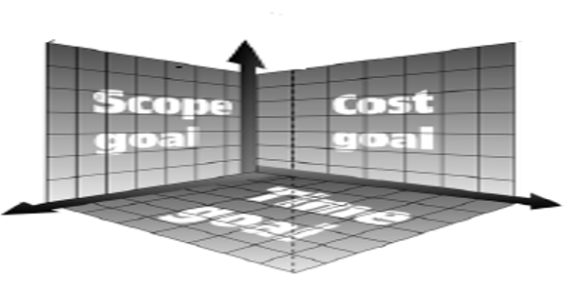

Project Phases
- Initiating Phase: Decide the project idea, goals, and basic requirements and officially start the project.
- Planning Phase: Decide what needs to be done, how it will be done, when it will be done, and what resources are needed.
- Executing Phase: Perform the planned work and create the project deliverables.
- Controlling Phase: Monitor and check the project progress, manage changes, and make sure the project stays on track.
- Closing Phase: Complete the project, deliver the final product, get approval, and formally close the project.
Links among processes (phases)
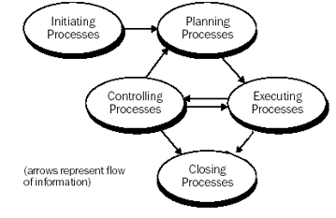

Lecture 3
The 4 Ps in PM Spectrum (1)
The 4 Ps in PM Spectrum
- People
- Product
- Process
- Project
People
Stakeholders: People who are affected by the project or have an interest in it.
Example: Customer, client, company owner, manager.
Team Leaders: People who lead and guide the software team. They assign tasks, monitor progress, and help solve problems.
Software Team: The group of people who actually work on developing the software.
Example: Developers, testers, designers, database engineers.
People
- People: The most important factor in the success of a software project.
- Companies that manage their investment in people wisely will prosper in the long run.
- Software organizations should develop and maintain motivated and highly skilled software professionals.
- The people factor is so important that the Software Engineering Institute (SEI) developed the People Management Capability Maturity Model (People-CMM).
PM-CMM
PM-CMM: People Management Capability Maturity Model.
Organizations that achieve a high level of maturity in PM-CMM are more likely to use effective software engineering practices.
Key Practice Areas of PM-CMM
PM-CMM has several key practice areas related to managing people:
- Recruiting: Finding and attracting suitable people for the organization.
- Selection: Choosing the right person for a specific job.
- Performance Management: Monitoring and improving employees' work performance.
- Training: Providing employees with the knowledge and skills they need to perform their jobs effectively.
- Compensation: Giving employees appropriate salary, rewards, and benefits for their work.
- Organizational Design: Organizing roles, responsibilities, and teams in an effective way (Hierarchy like leader, Manager etc).
- Career Development: Helping employees improve their skills and progress in their careers.
- Team/Culture Development: Building effective teams and creating a positive work culture.
- Work Environment: Creating a safe, supportive, and comfortable workplace where employees can work effectively.
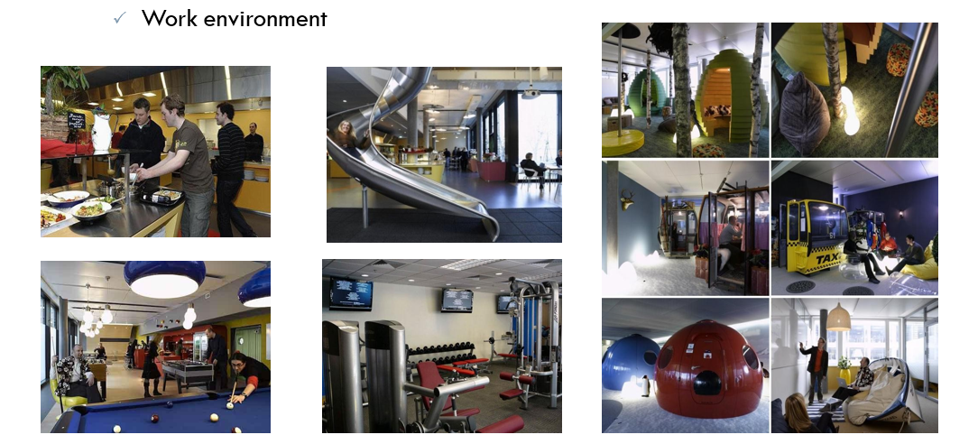
Peoples involved in Software Process
- Stakeholders
- Team Leaders
- Software Team
The Stakeholders
Stakeholders are people who are involved in a software project or are affected by it.
They can be categorized into the following:
- Senior Managers: They define important business issues and have significant influence on the business.
- Project (Technical) Managers: They plan, motivate, organize, and control the people who perform the software work.
- Practitioners: They provide the technical skills needed to develop the software product or application.
- Customers: They specify the requirements of the software that needs to be developed.
- End Users: They interact with and use the software after it is released for production.
The Team Leaders
Competent practitioners can sometimes become poor team leaders because they may not have the right combination of leadership skills.
Jerry Weinberg suggested the MOI Model of Leadership, which has three main parts:
MOI Model of Leadership
1. M: Motivation
Encourage technical people to do their work.
Motivation can be through “push” or “pull” methods.
- Push: Directly tell or pressure people to complete their work.
Example: “Complete this coding task by 5 PM today.”
- Pull: Encourage and motivate people so they want to complete their work.
Example: “Let’s finish this feature today so we can successfully complete our project on time.”
2. O: Organization
- Organize the team and work properly.
- Apply and improve processes efficiently.
- Example: A team leader divides the project into tasks, assigns each task to the right team member, and sets deadlines to make sure the work is completed smoothly.
3. I: Ideas or Innovation
- Encourage people to be creative.
- Create an environment where people feel comfortable sharing new ideas.
- Be creative.
- Example: A team leader asks team members for different ideas to improve the software and allows them to suggest new features or better ways of solving a problem.
The Team Leaders (Characteristics of an effective project managers)
1. Problem Solving
- Diagnostic: Ability to identify and understand the problem.
- Skill to solve: Ability to find a suitable solution to the problem.
- Ability to design solution: Ability to plan and create a solution for the problem.
Example: If the software has a login error, the team leader identifies the cause, finds a solution, and plans how to fix it.
2. Managerial Identity
- Meaning: The ability to take responsibility and control the project.
- The team leader manages the team's work, tasks, time, and progress.
3. Achievement
Reward Initiative: Give appreciation or rewards to team members who take initiative and do good work.
- Example: A developer finds and fixes a problem without being asked, so the leader appreciates their effort.
Encourage Controlled Risk Taking: Encourage team members to try new ideas while keeping the risks under control.
- Example: Allow a developer to test a new technology on a small part of the project before using it in the whole project.
4. Influence and Team Building
Influence the Team: Guide and motivate team members to work toward the project goals.
- Example: Encourage the team to work together to complete an important feature.
Read People’s Mind and Respond According to Their Needs: Understand how team members are feeling and respond appropriately.
- Example: If a team member is struggling with a task, the leader understands the problem and provides help.
Be Controlled in Stress Situations: Stay calm and make sensible decisions when problems or pressure occur.
- Example: If the project deadline is close and a major bug appears, the leader stays calm and organizes the team to fix it.
The Software Teams
Organizations/Structure of teams:
- Democratic decentralized
- Controlled decentralized
- Controlled centralized

Democratic Decentralized
- No permanent leader (No hierarchy): There is no fixed team leader. Leadership can change depending on the task.
- Communication is horizontal: Team members communicate directly with each other and have equal importance.
- Suitable for small projects: It is suitable for small projects with fewer than 5–6 engineers, especially research-oriented projects.
Example: A small research team has 4 developers. There is no permanent leader, and all members discuss problems and make decisions together.

Pros
- Different members provide technical leadership: At different times, different team members take the lead based on their skills or the task.
- High morale and job satisfaction: Team members have more freedom and independence in their work, so they feel more satisfied.

Corns
Team members may spend too much time arguing or discussing small/unimportant issues because there is no fixed authority or leader to make the final decision.
Controlled Centralized
Defined Team Leader: There is a fixed team leader who manages and guides the team.
Problem Solving, Communication and Management by Team Leader: The team leader is mainly responsible for solving problems, managing the team, and making important decisions.
Communication is Vertical: Communication happens between the team leader and team members, usually from top to bottom or bottom to top.

Pros
The senior engineer or team leader divides the work among team members, checks their work, and combines their completed work into the final software product.

Corns
Too much responsibility & authority is assigned to leader, possibility of single point of failure
Controlled Decentralized
It combines ideas from Controlled Centralized and Democratic Decentralized structures.
- Defined Leader: There is a fixed team leader who manages and guides the team.
- Vertical communication: Between the leader and team members.
- Horizontal communication: Between team members themselves.
- Problem Solving is a Group Activity: Team members work together to find solutions to problems.
- Suitable for Large Organizations: This structure is useful for large projects or organizations with many team members.

Seven Factors for Planning Team Structure
Mantei describes seven factors that should be considered when deciding how to structure a software team:
- Difficulty of Task: How difficult or complex the software project is.
- Size of Resultant Code: How large the final software will be, usually measured by the number of lines of code.
- Time That Team Will Stay Together: How long the same team will work together on the project.
- Degree of Modularization: How much the software can be divided into separate modules or parts.
- Required Quality and Reliability: How much quality and reliability the final software must have.
- Rigidity of Delivery Date: How strict the deadline is for completing the project.
- Degree of Communication: How much communication and coordination is needed between team members.
Communication & Coordination Issues
There are three ways team members communicate and coordinate with each other:
1. Formal Approaches
These are official and planned ways of communication.
- Writing: Using software documents, customer requests, reports, etc.
- Status Review Meetings: Meetings to discuss the progress of the project.
- Design and Code Inspections: Checking the design and code to find errors or problems.
- Example: A team holds a weekly meeting to discuss what has been completed and what remains.

2. Informal Approaches
These are more personal and less formal ways of communication.
- Interpersonal Networking: Team members communicate and build relationships with each other.
- Sharing Ideas on Ad Hoc Basis: Sharing ideas whenever needed, without a planned meeting.
- Seeking Help: Asking someone inside or outside the team for help when a problem occurs.
- Example: A developer asks another developer for help when they are stuck on a coding problem.

3. Electronic Communication
Communication using electronic tools.
- E-mail: Sending messages, documents, and updates.
- Electronic Bulletin Boards: Sharing information or announcements electronically.
- Video Conferencing: Communicating through online video meetings.
- Example: Team members in different cities use a video conference to discuss the project.

The Product
- Software Scope
- Problem Decomposition
The Product
At the beginning of a software project, we need to understand two things:
- The Product: What software we are going to build.
- The Problem: What problem this software will solve.
Scope of the Product
The scope means defining what the software will do and what its limits are.

Bounded scope means clearly setting the limits of the product.
It includes:
Quantitative data: Define measurable limits.
- Example: Maximum 1,000 simultaneous users.
- Example: Maximum 2 seconds response time.
Constraints and limitations: Identify restrictions that the project must follow.
- Example: Limited budget, technology, or hardware.
Mitigating factors: Identify things that can reduce or control the effects of possible problems.
- Example: Having a backup server if the main server fails.
Decompose the Problem
The problem should be broken into smaller parts so that each part can be understood and solved easily.
Software Scope
Scope means defining what the software will do, where it will be used, and what its limits are.
Scope is defined by:
1. Context
- Meaning: Defines where the software fits within a larger system, product, or business.
- It also identifies the constraints or limitations involved.
- Example: A hospital management system is part of the hospital's overall system and must follow hospital rules.
2. Information Objectives
- Meaning: Defines what data the software needs as input and what data it should produce as output.
- Example: Input: Patient information → Output: Patient report.
3. Function and Performance
- Function: Defines what the software does with the input to produce the output.
- Performance: Defines how well and how quickly the software should perform.
- Example: A search system takes a product name as input and displays matching products as output within 2 seconds.
Problem Decomposition
- Also called: Partitioning or Problem Elaboration.
- Meaning: Breaking a complex problem into smaller and easier parts.
- This activity is an important part of requirements analysis.
- It follows the Divide and Conquer approach for complex problems.
- A complex problem is divided into smaller problems that are easier to understand and manage.
- Decomposition makes planning easier because each small part can be planned separately.
Decomposition is done in 2 major areas:
- Functionality that must be delivered:
Identify what the software needs to do.
- Process that will be used to deliver the product:
Identify how the software will be developed and delivered.

Lecture 4
4 Ps in PM Spectrum (2)
The Process
- Process
- Framework Activities
- Process Models
- Process Decomposition
The Process
A software process provides a basic framework from which a complete plan for software development can be created.
Common process framework activities used in all software projects:
- Communication: Discussing with the customer and understanding their requirements.
- Planning: Deciding what needs to be done, when it should be done, and what resources are needed.
- Modeling: Creating designs and models of the software before development.
- Construction: Writing the code and testing the software.
- Deployment: Delivering the software to users and getting their feedback.
Framework Activities
These are the main activities of a software process and are used in all software projects.
- Communication:
- Planning
- Modeling
- Construction
- Deployment
These activities are applied to different software engineering tasks, such as developing different functions or features of the software.

Process Models
Different process models are used for software development, such as:
- Linear Sequential: Development is done step by step.
- Prototyping: A sample version of the software is created first.
- RAD (Rapid Application Development): Software is developed quickly using reusable components.
- Spiral: Development is done in repeated cycles with a focus on risks.
- Formal: Uses mathematical methods to develop software.
The project manager decides which process model to use based on:
- Customers: Who requested the product.
- People: Who will work on the project.
- Product: The characteristics and requirements of the product.
- Project environment: The conditions in which the project will be developed.
Project planning begins after the process model is selected.
Process Decomposition
The way a process is divided into smaller tasks depends on the complexity of the project.
Decomposition means breaking each framework activity into smaller work tasks that need to be completed.
Example: Communication Activity for a Simple Project
- Develop a list of clarification issues: Make a list of things that need to be clarified.
- Meet with the customer: Discuss the clarification issues with the customer.
- Develop statement of scope: Work together to define what the project will include.
- Review the statement of scope: Check the scope with everyone involved.
- Modify the statement of scope: Make changes if required.
The Project
- Project
- Signs of Projects Risk
- How to Avoid Project Risks
The Projects
- Software projects must be planned and controlled properly to avoid problems and complexity.
- Project managers and engineers must understand the important factors for project success.
- They should use a practical approach (doing what is realistic and useful for successfully completing the project) for planning, monitoring, and controlling the project.
Signs of Project Risk
John Reel describes ten signs that show a software project may be in danger:
- Software people don’t understand customer needs: The team does not clearly understand what the customer wants.
- Product scope is poorly defined: It is not clear what the software should include.
- Changes are managed poorly: Changes are made without proper planning or control.
- The chosen technology changes: The technology being used for the project keeps changing.
- Business needs change: The business requirements or goals change during the project.
- Deadlines are unrealistic: The project has deadlines that are difficult or impossible to meet.
- Users are resistant: Users do not want to accept or use the new software.
- Sponsorship is lost: The people supporting or funding the project stop supporting it.
- Team lacks skills: Team members do not have the required skills for the project.
- Managers avoid best practices: Managers do not follow proven and recommended ways of managing software projects.
How to Avoid Problems?
1. Start on the Right Foot
- Understand the project: Have a detailed understanding of what the project requires.
- Set realistic objectives and expectations: Set goals and deadlines that are achievable.
- Select the right team: Choose people who have the required skills.
- Facilitate the team: Provide the team with the resources and support they need.
2. Maintain Momentum
- Provide incentives: Encourage and motivate team members.
- Reduce bureaucracy: Avoid unnecessary rules and paperwork.
- Give autonomy with supervision: Allow team members to make decisions while still monitoring their work.
3. Track Progress
- Assess progress: Regularly check the project's progress as work products are completed.
4. Make Smart Decisions
- Use existing software components: When possible, use already available software or COTS (Commercial Off-The-Shelf) (ready-made software that you can buy ) software instead of creating everything from scratch.
- Choose standard approaches: Use common and proven methods, and keep the project simple.
- Avoid risks: Identify risks and give extra time to complex or risky tasks.
5. Conduct a Postmortem Analysis
- A postmortem analysis is done after the project to understand what went well and what went wrong.
- Compare planned and actual schedule: Check whether the project was completed according to the planned time.
- Collect and analyze project metrics: Collect project data and compare it with standards.
- Get feedback: Ask team members and customers about their experience.
- Record lessons learned: Write down what was learned so it can help in future projects.
W5HH Principle
Suggested by Barry Boehm in one of his papers.
It is an excellent planning outline for project managers and software teams.
It can be applied to all sizes of software projects.
W5HH Principle helps address:
- Project objectives: What do we want to achieve?
- Milestones & schedule: When should each task be completed?
- Responsibilities: Who will do each task?
- Management & technical approaches (Top up or Bottom Down): How will the project be managed and developed?
- Required resources: What resources are needed for the project?
W⁵HH principle
W — Why is the system being developed?
- Helps check whether there is a valid business reason for developing the software.
- Determines whether the business purpose is worth the people, time, and money spent on the project.
W — What will be done?
- Identifies the tasks that need to be completed for the project.
W — When will it be done?
- Helps create the project schedule.
- Identifies when tasks should be completed and when milestones should be reached
W — Who is responsible for a function?
- Defines the roles and responsibilities of each team member.
W — Where are they organizationally located?
- Shows where each person or group is located in the organization (identifies which department or group each person belongs to).
- Responsibilities are not limited to the software team; customers, users, and stakeholders also have responsibilities.
H — How will the job be carried out technically and managerially?
- After defining the product scope, a technical and management strategy is decided.

H — How much of each resource is needed?
- Determines how much time, people, money, and other resources are required.
- These estimates are based on the answers to the earlier questions.

